 | 12.1.25 Editors - Geometry Nodes Editor - Header - Node menu
Table of content
Node menu 2
Move 2
Rotate 2
Resize 2
Copy 2
Paste 2
Duplicate Keep Input 2
Duplicate 2
Delete 2
Delete with Reconnect 2
Join new Frame 3
Remove from Frame 3
Frame Make Parent 3
Links 3
Make Links 3
Make and Replace Links 3
Detach Links 3
Detach Links Move 3
Mute Links 3
Separate 3
Copy 3
Move 3
Hide / Toggle 4
Hide 4
Toggle Node Mute 4
Toggle Node Preview 4
Toggle hidden node sockets 4
Toggle Node Options 4
Collapse and Hide Unused Sockets 4
Render View Layers 4
Render changed Layer 5

Node menu
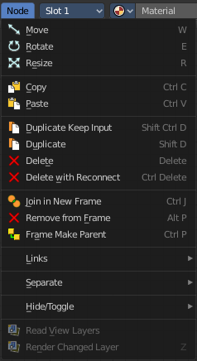
This menu contains further node functionality.

Move
Moves the selected nodes.

Rotate
You can't rotate single nodes, obviously. But when you have more than one selected then you can rotate them around their center point.

Resize
You can't resize single nodes, obviously. But when you have more than one selected then you can scale them around their center point.

Copy
Copies the selected node(s).

Paste
Pastes the selected node(s).

Duplicate Keep Input
This works at nodes that have a connected input. Duplicating will keep the input connections established in the duplicated node. The output connections will be removed.

Duplicate
Duplicates the selected node(s). All connections will be removed in the duplicated node.

Delete
Deletes the selected node(s).

Delete with Reconnect
Deletes the selected node(s). When this node is in the middle of a connection, then the connections will be reconnected.

Join new Frame
Frame node functionality. Adds the selected node to a frame.

Remove from Frame
Frame node functionality. Removes the selected node from a frame.

Frame Make Parent
Frame node functionality. Adds the selected node to a frame.

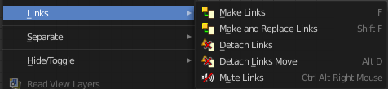
Links

Make Links
Tries to connect nodes where it makes sense.

Make and Replace Links
Same as Make Links. But it will replace existing links.

Detach Links
Removes all connections from the selected node, but tries to reconnect the remaining nodes.

Detach Links Move
Removes all connections from the selected node by dragging.

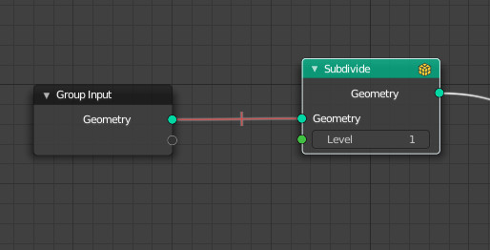
Mute Links
Allows you to mute links instead of disconnecting it by painting over the link connection. To unmute, use the tool again. Hotkey only tool. Please use the hotkey.


Separate
Node group functionality. You need to be in edit group mode.

Copy
Copies the selected node, and pastes a copy of it outside of the node group. The node group remains unchanged.

Move
Moves the selected to outside of the node group, and removes it from the node group.


Hide / Toggle
Here you find hide options to make the display of nodes
more compact.


Demonstration happens at an image node.


Hide
Hides everything but input and output dots. To view the full node again perform the operator again. It's a toggle. Or click at the triangle left besides the node name.


Toggle Node Mute
Deactivates the node.

Toggle Node Preview
This is a compositor feature for the preview image. It does not belong here, but shares the same menu. It shows or hides the preview image.

Toggle hidden node sockets

Toggles away the unused node sockets. In this case the vector input node socket and the alpha output node socket will be hidden.


Toggle Node Options
Hides away the properties.


Collapse and Hide Unused Sockets
Like Hide. Hides everything but the node sockets. But it also hides the unused node sockets.

Render View Layers
This is a compositing feature that does not belong to the Geometry Nodes editor. It shares the menu with the Compositor Editor though. And so you see this menu items. It is deactivated. You can't use it in the Shader Editor.

Render changed Layer
This is a compositing feature that does not belong to the Geometry Nodes editor. It shares the menu with the Compositor Editor though. And so you see this menu items. It is deactivated. You can't use it in the Geometry Nodes Editor.

